**Committee of Adjustment Public Hearing for a Minor Variance Application**

**Take Notice** that the North Kawartha Committee of Adjustment is holding a public hearing to consider an application for a Minor Variance under Section 45 of the Planning Act R.S.O. 1990, Chap. P. 13 as amended.

Date: Committee of Adjustment Regular Meeting March 4, 2025

Time: 8:30 a.m.

Location: Hybrid (In-person at the Council Chambers, 280 Burleigh Street, Apsley and Electronically via Zoom or by phone).

Application A-03-25 (Taylor)

Part of Lot 3, Concession 8, Burleigh Ward

65 Fire Route 20

Roll # 1536-020-001-82300

**The Purpose and Effect** of Minor Variance application A-03-25 is to facilitate the construction of a one-storey screened porch addition and attached decks at the south side of the existing dwelling. The proposed addition and decks would have a total area of 37.7 square metres (406 square feet). The application seeks a lateral width of 22.9 metres (75 feet) whereas dwellings located with 9 to 15 metres (30 to 50 feet) of the high-water mark may be expanded in lateral width to a maximum of 18.3 metres (60 feet).

**A Key Map** showing the location of the lands subject to this application is provided on a subsequent page of this notice.

**Additional Information:** Meetings are held in a hybrid format and are open to the public. The zoom invitation is available on the current agenda page (link below) for those wishing to attend or participate in the meeting electronically.

View the current agenda: [www.northkawartha.ca/currentcouncilagenda](http://www.northkawartha.ca/currentcouncilagenda) Subscribe to receive all planning notices: [www.northkawartha.ca/subscribe](http://www.northkawartha.ca/subscribe)

Persons attending the meeting will be provided an opportunity to submit verbal comments in support or in opposition to the application. Written submissions may be made **no later than 4:00 p.m. on the day prior to the meeting** to: [planning@northkawartha.ca](mailto:planning@northkawartha.ca), or Fax: (705) 656-4446, by mail or in person: PO Box 550, 280 Burleigh Street, Apsley, ON K0L 1A0 (Note: Dropbox located to the right of the front door). Further details and a convenient form are available on the Township website: [www.northkawartha.ca/commentsorappeals](http://www.northkawartha.ca/commentsorappeals)

To be notifiedof the decision of the Committee on the proposed minor variance, send a written request to: [planning@northkawartha.ca](mailto:planning@northkawartha.ca) or Fax: (705) 656-4446 or by mail or in person: PO Box 550, 280 Burleigh Street, Apsley, Ontario K0L 1A0 (Note: Dropbox to the right of the front door).

Dated at the Township of North Kawartha this 19th day of February, 2025.

Emily Fitzgerald, Junior Planner

Township of North Kawartha

280 Burleigh Street, P.O. Box 550

Apsley, ON K0L 1A0

(705) 656-5183

[e.fitzgerald@northkawartha.ca](mailto:e.fitzgerald@northkawartha.ca)

**Personal Information** is collected under the authority of the *Planning* Act and will become part of the public record and may be made available for public viewing or distribution. Meetings are recorded and posted the Township You Tube Channel for public viewing. Any opinions you express may be made available to the public.

Requests for alternate formats or other accessibility accommodations, can be made to the Clerk at: (705) 656-5187 or by email to [c.parent@northkawartha.ca](mailto:c.parent@northkawartha.ca)

**Key Map**

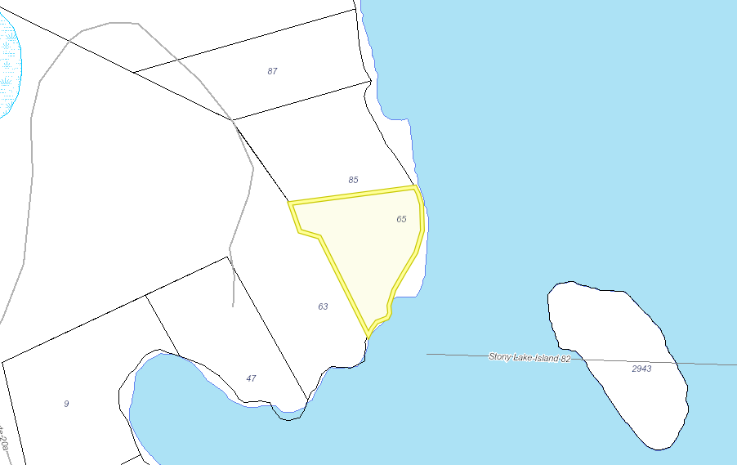

Subject Property